TESTING TOOLS MANUAL

### Testing:

* The process of identifying the bugs in a software (project/product) is known as

*“Testing”.*

* The Test Engineer has to cross check (validate) whether the developed software is as per the clients requirements or not. He is responsible to deliver quality software to the client.

**Note: The main responsibility of the test engineer is, he has to check(validate) whether the developed application (software) is useful for end user or not.

**Bug:** The deviation from the requirement is known as the bug or defect.

**Quality:** Justification of all the client requirements with user friendliness and security is known as *quality*.

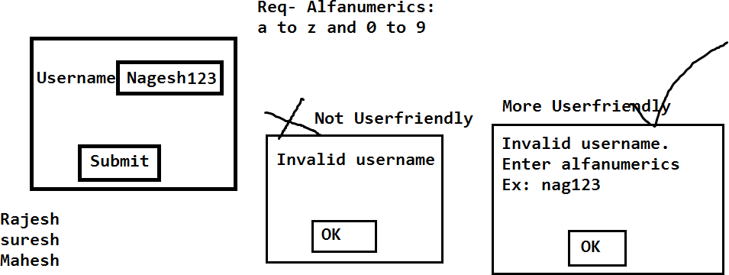

**Let’s take an example**: Delivered/Released

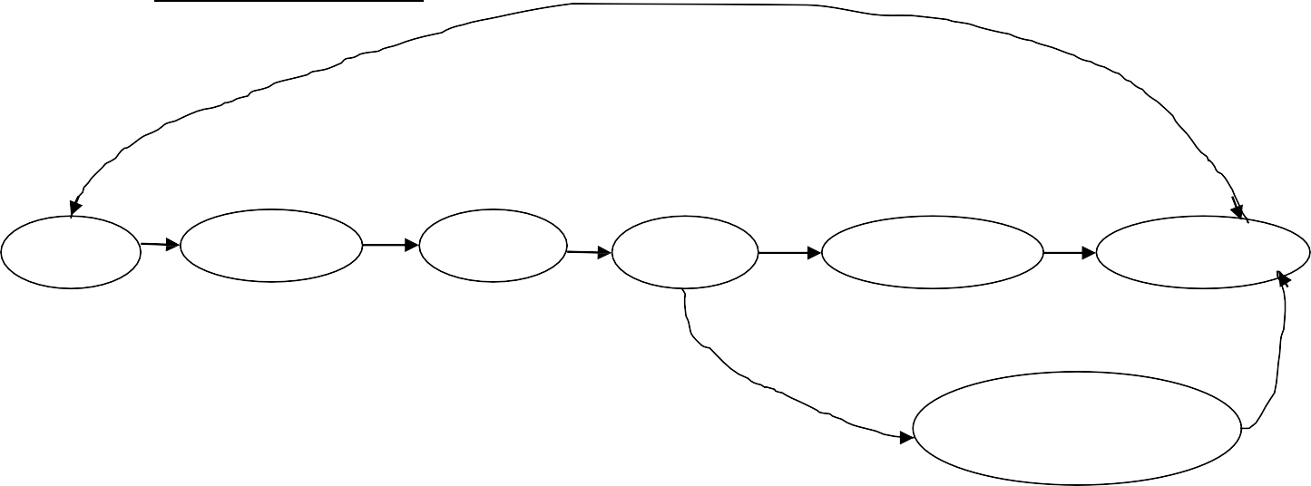

Business Analyst

Required Document Company

DeveloperProject/product

Me

Architect

Plan

Builder

Constructer

Home

Client

Plan

Supervisor

### Project:

Test Engineer

It will be developed based on the client’s requirements; once it is developed it will be delivered to the client. Based on the clients need the team members (End users) will use it.

Ex: Spicejet.com, selenium4testing.com, Constructing own house with our requirements.

### Product:

It will be developed based on the company’s requirements. Once it is developed, it will be released in the market based on the customer needs they will choose the product.

Ex:Mobile App, Calculator, Facebook, yahoo, MS Office, Mac operating system, windows operating system, Gmail etc…

### Testing types:

Testing Tools



Functional Testing Non-Functional Testing

Load Testing Manual Testing Automation Testing Performance testing



Selenium, win runner Stress Testing

QTP, RFT, silktest, Water, Watin Soak Testing

### Internet based Applications:

These Applications can be accessed worldwide with unlimited number of users.

Ex: Gmail, Facebook, selenium 4testing

### Intranet based Applications:

These applications also can be accessed worldwide, But with limited number of users.

Ex: Applications which are limited to a specific organization.

### Bidding of the project:

Roles Involved:

1. Marketing Business Analyst(BA)
2. Engagement Manager(EM)

* Marketing Business Analyst(BA):

Marketing BA will meet the client and convince the client with the proposal. Once the client is satisfied with the proposal then the client and company will sign off the project.

**Sign Off**:

The official agreement between the client and company about the project delivery is known as ‘*sign off’*.

**KickOff Meeting:**

Once the project is signed off company will go for a ‘*kickoff’* meeting. It’s a quick meeting where all the high level management will participate and they will announce the project, client and they will choose the project manager for the project. The project manager is responsible for SDLC.

* Engagement Manager(EM):

Engagement Manager is responsible to maintain the relationship between the client and company. He acts as a bridge between the Client and the Company.

#### Bidding of the project

1 Cr

Proposal



Client

1 year

C1

C2

C3

About company History Estimations Time & Cost

Sign off

Kick off Meeting

|  |  |  |  |
| --- | --- | --- | --- |
| 2cr | 1.5 cr | 1 cr | Project Manager |
| 2 years | 1.5 years | 1 year |  |

#### Project hierarchy or Designation hierarchy or Role hierarchy

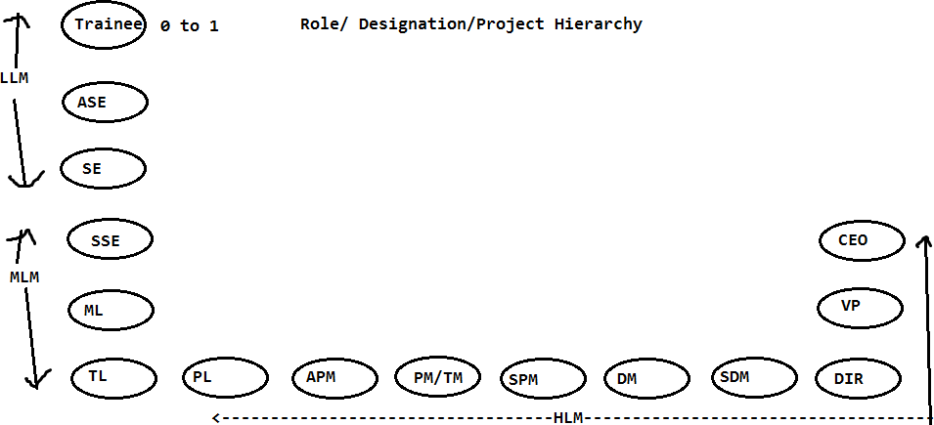

LLM: Low level Management MLM: Middle level Management HLM: High level Management